

**Student Management System**

**Version 1.0**

**Prepared by**

**Phan Anh Tuấn – SE1422**

1

Contents

1. Document description 3

2. SRS overview 3

2.1. List of system users 3

2.2. List of use cases 3

2.3. Use case diagram 4

3. Data model 5

3.1. Entity Relationship Diagram 5

3.2. Database Diagram 6

3.3. Table details/Chi tiết các bảng 6

2

# Document description

This document describes requirements and functions for Student Management System. It is divided into the following sections:

* In the section 2 an overview of the Student Management system’s requirements will be provided, including list of system users, use cases, use case diagram.
* In the section 3 an E-R diagram and all tables of the Student Management system in detail will be presented.

# SRS overview

## 2.1. List of system

1. Categories: Admin add subjects, majors-classes, teachers and students.

2. Marks: Admin edit student mark’s corresponding to exercise name

3. System: Admin manage account/ Admin and Member can change password and log out

4. View Student: Admin and User can search student information’s

## 2.2. List of use cases

1. Login/Logout

2. Change password

3. Manage account

4. Search student information

5. Edit student marks

6. Manage subject

7. Manage majors and class

8. Manage teacher

9. Manage student

10. Manage exercise

## 2.3. Use case diagram

3

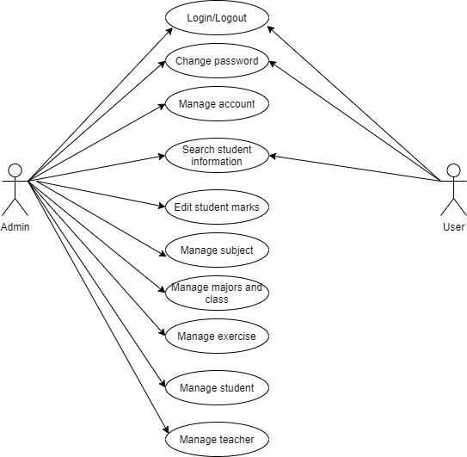

4

# Data model

## Entity Relationship Diagram

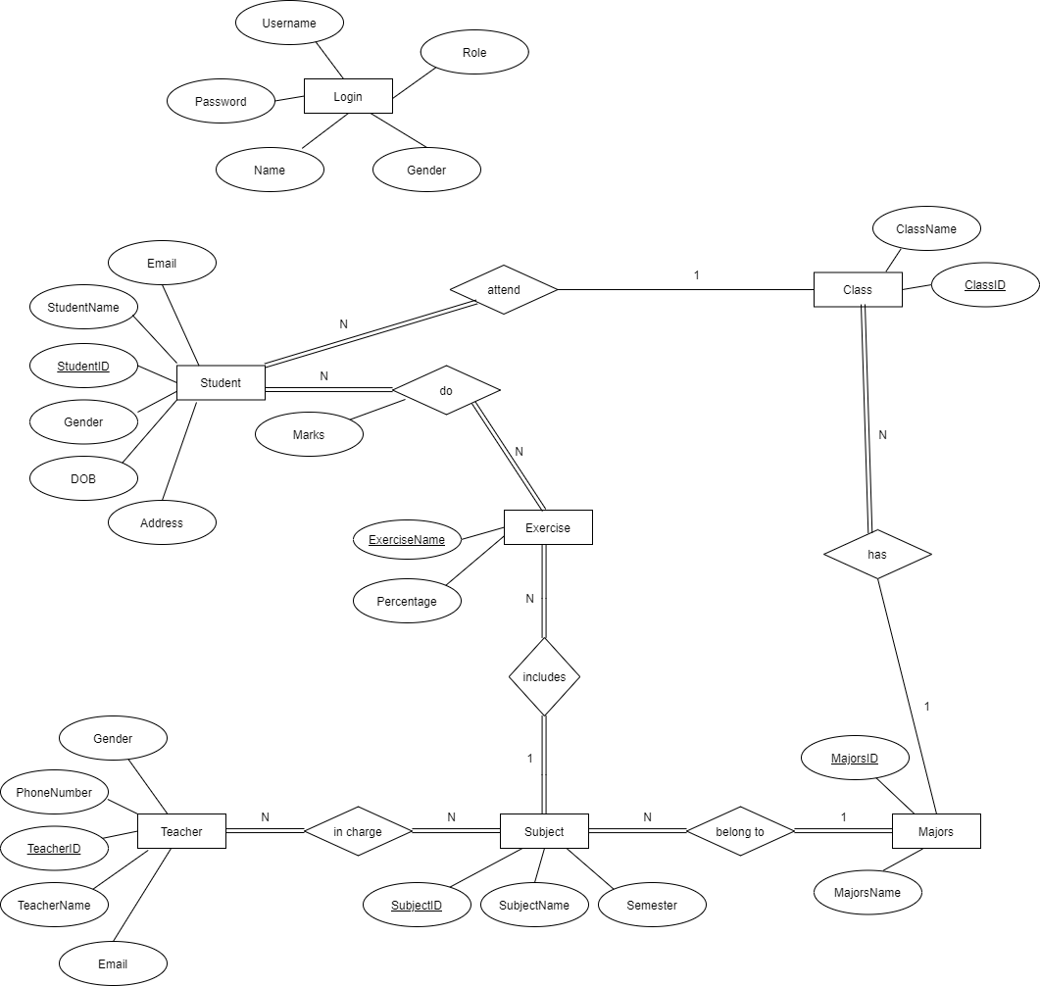

5

## Database Diagram

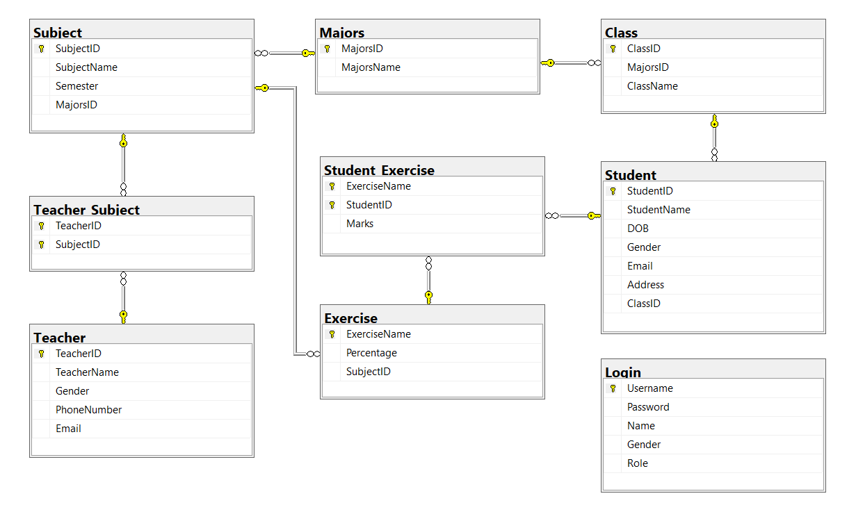

## Table details/Chi tiết các bảng

### Table name: Majors

|  |  |  |  |
| --- | --- | --- | --- |
| **Field name** | **Type** | **Size** | **Note** |
| MajorsID | String | 10 | Primary key |
| MajorsName | String | 50 | Not null |

### Table name: Class

|  |  |  |  |
| --- | --- | --- | --- |
| **Field name** | **Type** | **Size** | **Note** |
| ClassID | String | 50 | Primary key |
| MajorsID | String | 10 | Foreign key, refers to Majors table |
| ClassName | String | 50 | Not null |

6

### Table name: Login

|  |  |  |  |
| --- | --- | --- | --- |
| **Field name** | **Type** | **Size** | **Note** |
| Username | String | 50 | Primary key |
| Password | String | 50 | Not null |
| Name | String | 50 | Allow null |
| Gender | String | 50 | Allow null |
| Role | String | 50 | Allow null |

### Table name: Exercise

|  |  |  |  |
| --- | --- | --- | --- |
| **Field name** | **Type** | **Size** | **Note** |
| ExerciseName | String | 10 | Primary key |
| Percentage | String | 10 | Not null |
| SubjectID | String | 10 | Not null, Foreign key, refers to Subject table |

### Table name: Student_Exercise

|  |  |  |  |
| --- | --- | --- | --- |
| **Field name** | **Type** | **Size** | **Note** |
| ExerciseName | String | 10 | Primary key |
| StudentID | String | 50 | Primary key |
| Marks | String | 10 | Not null |

7

### Table name: Student

|  |  |  |  |
| --- | --- | --- | --- |
| **Field name** | **Type** | **Size** | **Note** |
| StudentID | String | 50 | Primary key |
| Name | String | 50 | Not null |
| DOB | String | MAX | Not null |
| Gender | String | 10 | Not null |
| Address | String | MAX | Allow null |
| ClassID | String | 50 | Not null |
| Email | String | 50 | Allow null |

### Table name: Subject

|  |  |  |  |
| --- | --- | --- | --- |
| **Field name** | **Type** | **Size** | **Note** |
| SubjectID | String | 10 | Primary key |
| SubjectName | String | 50 | not null |
| Semester | String | 10 | not null |
| MajorsID | String | 10 | Foreign key, refers to majors table |

### Table name: Teacher

|  |  |  |  |
| --- | --- | --- | --- |
| **Field name** | **Type** | **Size** | **Note** |
| TeacherID | String | 10 | Primary key |
| TeacherName | String | 50 | Not null |
| Gender | String | 10 | Not null |
| Phone | String | 20 | Allow null |
| Email | String | 20 | Allow null |

8

### Table name: Teacher_Subject

|  |  |  |  |
| --- | --- | --- | --- |
| **Field name** | **Type** | **Size** | **Note** |
| TeacherID | String | 10 | Primary key |
| SubjectID | String | 10 | Primary key |

9